Call center data

Technical Requirement Document

## Content

|  |
| --- |
| 1. Introduction 03 |
| 1.1Purpose of this document 03 |
| 1. Purpose of this Project 03 |
| 1. Scope 03 |
| 1. Data Preparation 04 |
| 1. Project Execution Procedure 06 |
| 1. Flow Chart of Preparation of Data 07 |
| 1. Data Uploading Issue 08 |
| 1. Data Validation 12 |
| 1. Power BI Desktop 13 |
| 1. Data preparation and Modeling 15 |
| 1. Business Requirements 16 |
| 1. Required Calculation 17 |
| 1. Report Building 19 |

## Introduction

## Purpose of this document

The objective of this documents is to **help you to understand your call centre demand, highlighting how many inbound and outbound calls are made over a specified period of time**.. This document serves models and reports for building solution to meet customer requirements as documented.

## Purpose of this Project

* Create call center dashboard show all this insghts & more.
* This report is a simulated 3-month view of operational metrics for a call center.
* Below is a glossary of terms to make the report more user-friendly.

1. Calls Handled:- Inbound call taken by an agent.
2. Avg Handle Time (or AHT):- Average time to complete a call.
3. Transfer %:- Percent of calls that resulted in a transfer out.
4. Offer %:- Percent of offers made on a call.
5. Accept %:- Percent of accepts on offers made.
6. Applied %:- Percent of applieds on accepted offers.
7. Breakage:- Percent of calls where an offer was not applied.
8. Applied Per Call %:- Percent of calls that had an applied offer.
9. Callback within 2 Days %:- Percent of calls where customer called back within 48 hours.

## Scope

A call center report helps organizations to take corrective measures to set internal targets, monitor agent performance levels and analyze efficiencies in various areas including complaint resolution, response rate, and overall productivity levels.

## Data Preparation

Data given by client that contains following information Data fact table: (excel file)

In that table having 17 columns which are given below

1) Data fact (excelfile)

* YR_MO
* CALL_DATE
* AGENT_ID
* TEAM_LEAD_ID
* CALL_CENTER
* CALLS
* HANDLE_TIME
* CALL_REGEN
* CALLS_WITH_OFFER
* CALLS_WITH_ACCEPT
* CALLS_OFFER_APPLIED
* TRANSFERS
* AHT_MULTI
* CALL_REGEN_MULTI
* TRANSFERS_MULTI
* APPLIED_PER_CALL_MULTI
* BREAKAGE_MULTI

2)Dimension Table:-

1)Agent:-

* Agent_id
* Agent_name

|  |  |
| --- | --- |
|  | 2)Team Leaders: |
|  | * Team_lead_id * Team_lead_name |
|  |  |

* Load the shared  data files into oracle database as it is.
* Decide the data type for SQL table creation from the shared file which data type should be there to load data into final table with appropriate data type.
* I have imported all the tables in oracle 11g database.

1. Data_fact table
2. Agent
3. Team_leaders

## Project Execution Procedure

## Flow Chart of Preparation of Data



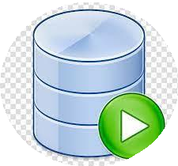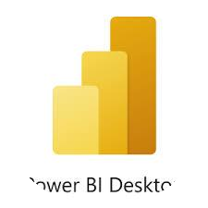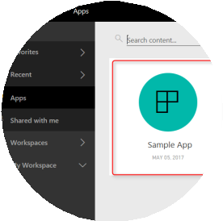

Importing Data from data source

Creation of Fact Table,Dimension Table,

Performing joins/Union all/create new table if required

Data cleaning ,Creation of Model,Dax

Calculation , Visualization like charts

,graph etc,

Publishing Report in to Power Bi Service

Creation of Apps and share to end user

## Data Uploading Issue

1. Create schema connection in oracle for the project.
2. Created a table structure in oracle for that data with proper datatype for each column then

import data into that table but there is issue with excel file having file type .xlsm which

is not supported in oracle 11g  so for solving that issue  convert the file type from .xlsm

to .xlsx now it is visible in oracle.

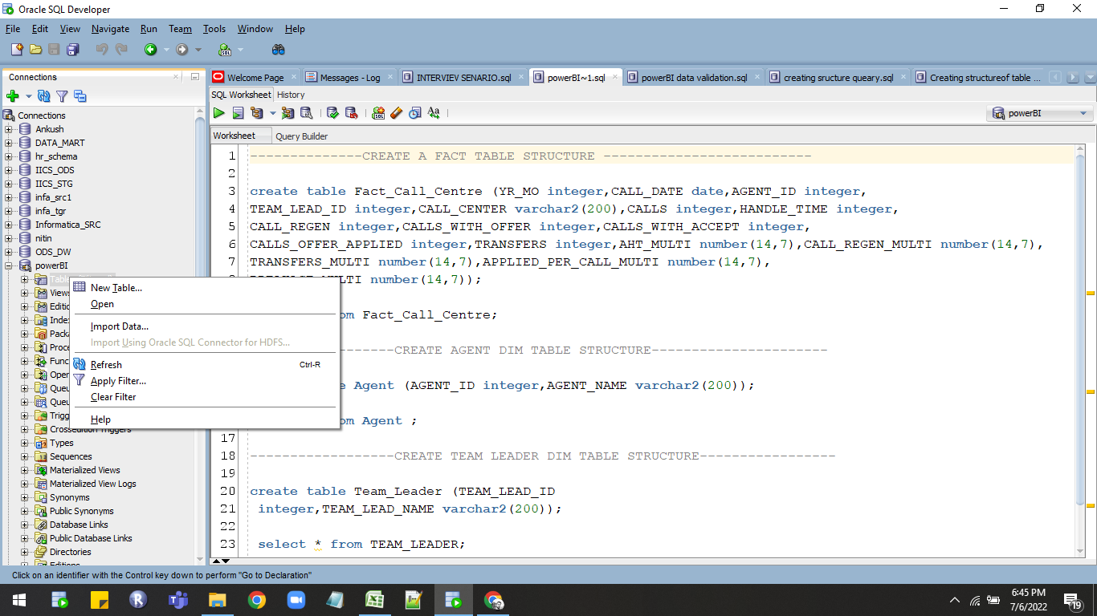

1. Then import the data into created table structure in that the fact table file contains blank

rows at top so skip that rows in data preview tab we have option like skip rows. use that option

to skip the top rows.

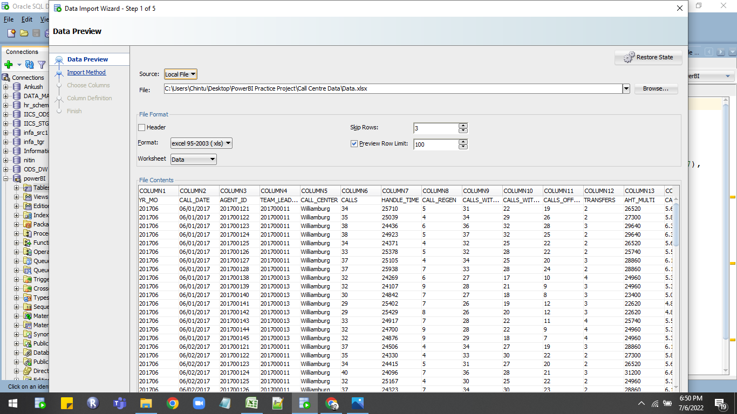

4. At the data table importing time check all the column datatypes properly Eg.date column with

proper date format like (DD/MM/YYYY).

1. In data there is decimal numbers in that column so for that column usethe number datatype

with proper scale and precision.

5. Query used in oracle.

--------------CREATE A FACT TABLE STRUCTURE --------------------------

create table Fact_Call_Centre (YR_MO integer,CALL_DATE date,

AGENT_ID integer,

TEAM_LEAD_ID integer,CALL_CENTER varchar2(200),CALLS integer,

HANDLE_TIME integer,

CALL_REGEN integer,CALLS_WITH_OFFER integer,CALLS_WITH_ACCEPT integer,

CALLS_OFFER_APPLIED integer,TRANSFERS integer,

AHT_MULTI number(14,7),CALL_REGEN_MULTI number(14,7),

TRANSFERS_MULTI number(14,7),APPLIED_PER_CALL_MULTI number(14,7),

BREAKAGE_MULTI number(14,7));

select * from Fact_Call_Centre;

------------------CREATE AGENT DIM TABLE STRUCTURE----------------------

create table Agent (AGENT_ID integer,AGENT_NAME varchar2(200));

select * from Agent ;

------------------CREATE TEAM LEADER DIM TABLE STRUCTURE-----------------

create table Team_Leader (TEAM_LEAD_ID

 integer,TEAM_LEAD_NAME varchar2(200));

 select * from TEAM_LEADER;

## Data Validation

* Data validation is **the practice of checking the integrity, accuracy and structure of data**

**before it is used for a business operation**. Data validation operation results can provide

data used for data analytics, business intelligence or training a machine learning model.

* Validate the data in excel in pivot table and in oracle using aggregate functions.
* Count of records in excel pivot table is 1525.

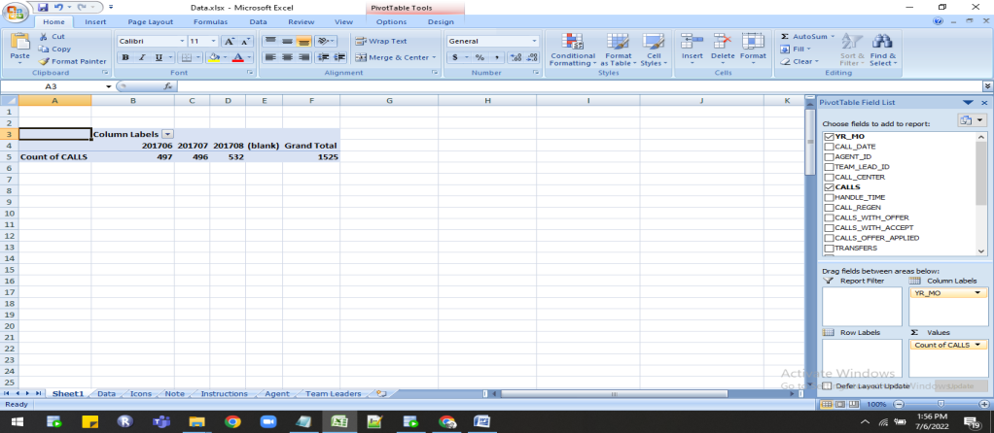

* Count of records in oracle is 1525 used aggregate function count.

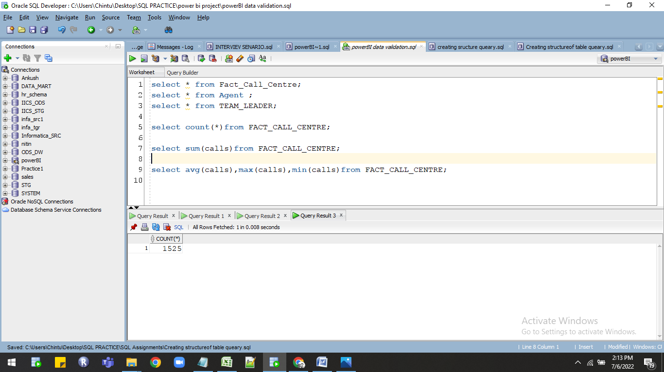

* Table showing fields which are validated in both excel and oracle.

|  |  |  |  |
| --- | --- | --- | --- |
| sr.no | Fields | Excel records | Oracle records |
| 1. | Sum of calls | 50482 | 50482 |
| 2. | Avg of calls | 33.1029 | 33.1029 |
| 3. | Max of calls | 40 | 40 |
| 4. | Min of calls | 28 | 28 |
| 5. | Sum of handled time | 38140644 | 38140644 |
| 6. | Avg of handled time | 25010.25836 | 25010.25836 |
| 7. | Max of handled time | 26000 | 26000 |
| 8. | Min of handled time | 24000 | 24000 |
| 9. | Sum of CALL_REGEN | 9976 | 9976 |
| 10. | Avg of CALL_REGEN | 6.541639344 | 6.541639344 |
| 11. | Max  of CALL_REGEN | 10 | 10 |
| 12. | Min  of CALL_REGEN | 3 | 3 |
| 13. | Sum of CALLS_ACCEPT | 35262 | 35262 |
| 14. | Avg  of CALLS_ACCEPT | 23.12262295 | 23.12262295 |
| 15. | Max  of CALLS_ACCEPT | 35 | 35 |
| 16. | Min of CALLS_ACCEPT | 14 | 14 |
| 17. | Sum of TRANSFERS | 3728 | 3728 |
| 18. | Avg  of TRANSFERS | 2.444590164 | 2.444590164 |
| 19. | Max of TRANSFERS | 4 | 4 |
| 20. | Min  of TRANSFERS | 1 | 1 |
| 21. | Sum of AHT_MULTI | 39337349 | 39337349 |
| 22. | Avg  of AHT_MULTI | 25794.98295 | 25794.98295 |
| 23. | Max  of AHT_MULTI | 31320 | 31320 |
| 24. | Min  of AHT_MULTI | 21700 | 21700 |
| 25. | Sum of BREAKAGE_MULTI | 10061.327 | 10061.327 |
| 26. | Avg of BREAKAGE_MULTI | 6.597591475 | 6.597591475 |
| 27. | Max of BREAKAGE_MULTI | 8.04 | 8.04 |
| 28. | Min  of BREAKAGE_MULTI | 5.544 | 5.544 |
| 29. | Sum of CALLS_WITH_OFFER | 46746 | 46746 |
| 30. | Avg  of CALLS_WITHOFFER | 30.65311475 | 30.65311475 |

* Query used in oracle for data validation.

select * from Fact_Call_Centre;

select * from Agent ;

select * from TEAM_LEADER;

select count(*)from FACT_CALL_CENTRE;

select count(calls),sum(calls),Avg(calls),Max(calls),Min(calls)from FACT_CALL_CENTRE;

select count(handle_time ),sum(handle_time),Avg(handle_time),Max(handle_time),Min(handle_time)from FACT_CALL_CENTRE;

select count(CALL_REGEN),sum(CALL_REGEN),Avg(CALL_REGEN),Max(CALL_REGEN)

,Min(CALL_REGEN)from FACT_CALL_CENTRE;

select count(TRANSFERS),sum(TRANSFERS),Avg(TRANSFERS),Max(TRANSFERS),

Min(TRANSFERS)from FACT_CALL_CENTRE;

select count(AHT_MULTI),sum(AHT_MULTI),Avg(AHT_MULTI),Max(AHT_MULTI),

Min(AHT_MULTI)from FACT_CALL_CENTRE;

select count(CALLS_WITH_OFFER),sum(CALLS_WITH_OFFER),Avg(CALLS_WITH_OFFER),Max(CALLS_WITH_OFFER),Min(CALLS_WITH_OFFER)from FACT_CALL_CENTRE;

## Data preparation and Modeling

1. Import the data in power BI desktop for importing data first you have to connect to oracle database.
2. To connecting data click on GET DATA option then select the DATABASE option after that select oracle database option then click on connect.

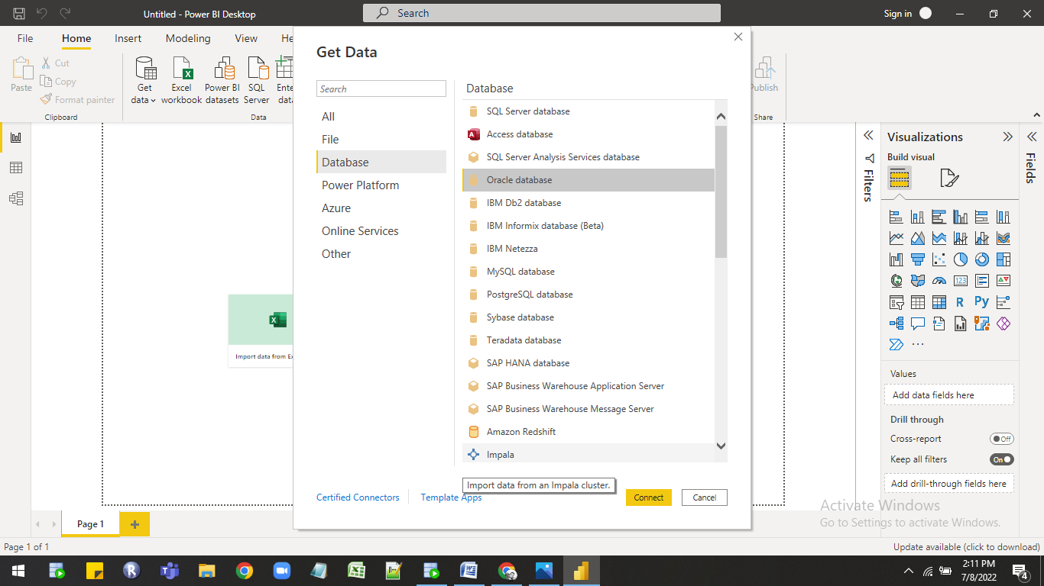

1. Then new window is open in that you have to give server name for e.g Localhost and

then you have to select data connectivity mode there are two modes

* import :- file size 1gb limit.
* Direct query:- No limit for file size.

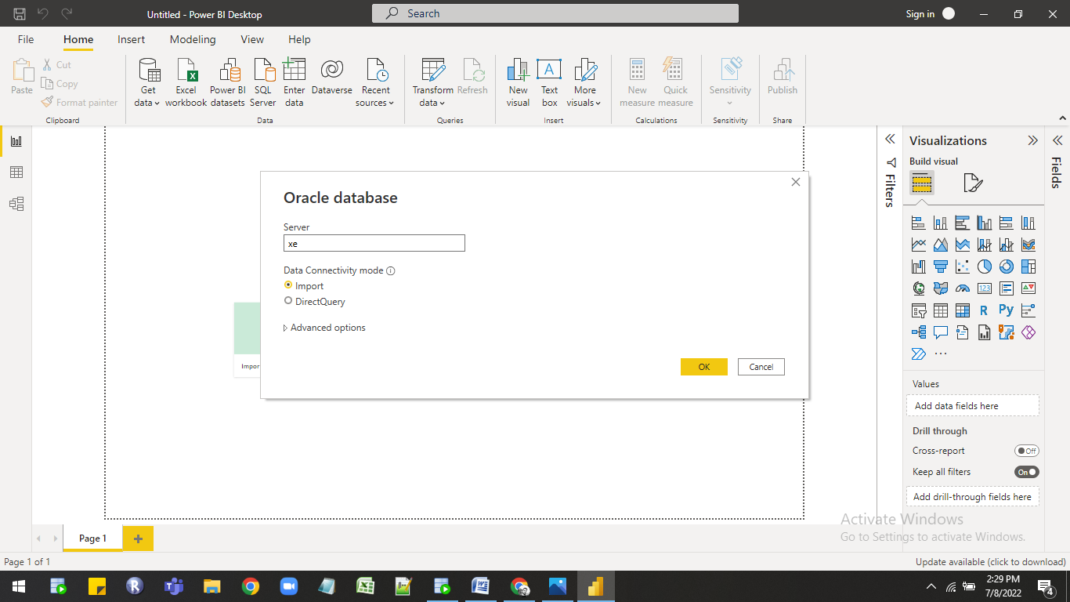

1. Select import option then click on ok then it will connect to oracle new window open in that you

can see the oracle schema with table list at left hand side from that list select the connection schema containing created tables then select whatever table you want to import in power bi they

are three options

1.Load:-If you do not want any transformation in data then you can use directly use load option.

2.Tranform:-Using transform option you can make changes in original data In power quary.

3.Cancel:- Using cancel option you can directly cancel the import.

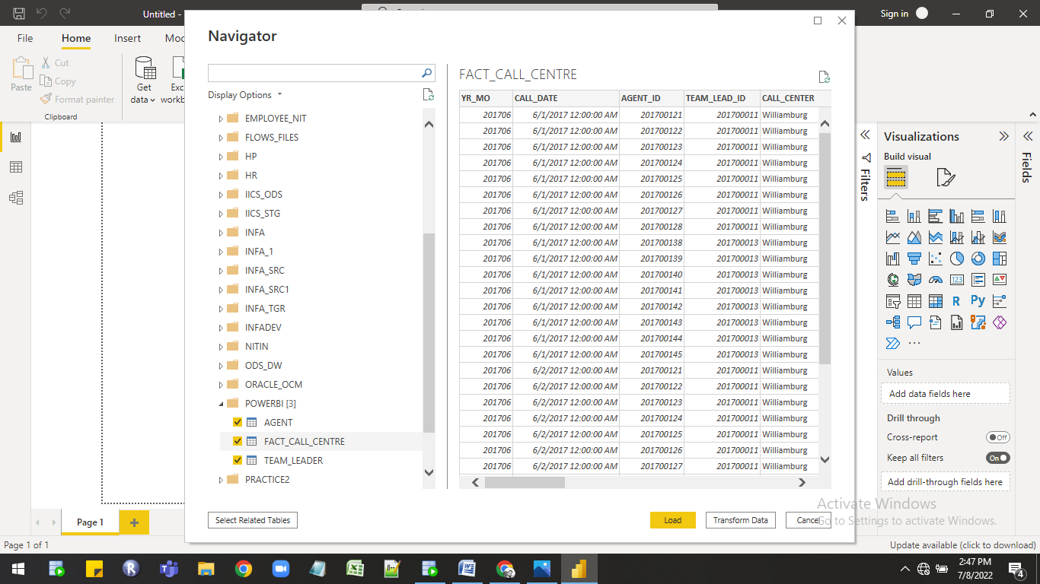

1. Click on Load option then data directly imported into power bi in power pivot stores compressed form in columnar database vertically.

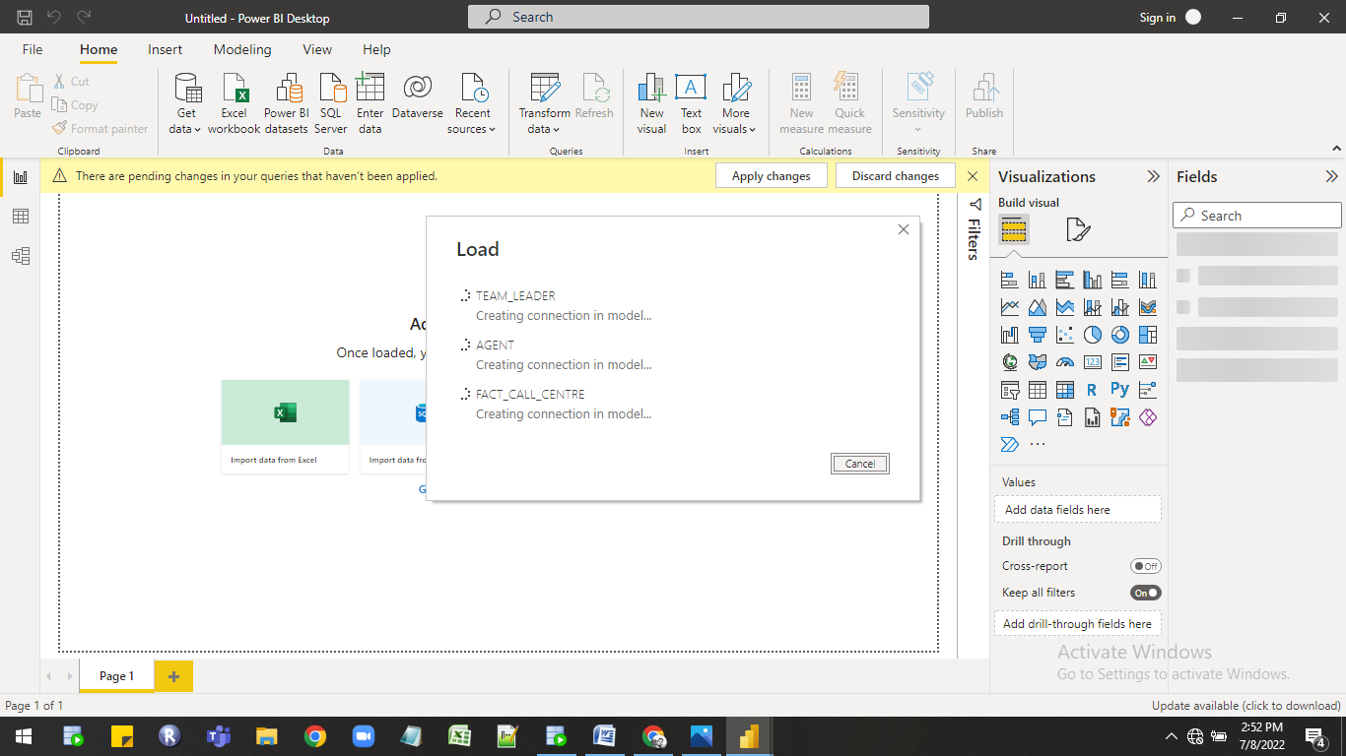

1. Tables are loded in power pivot click on manage relationship option for making relationship between tables.

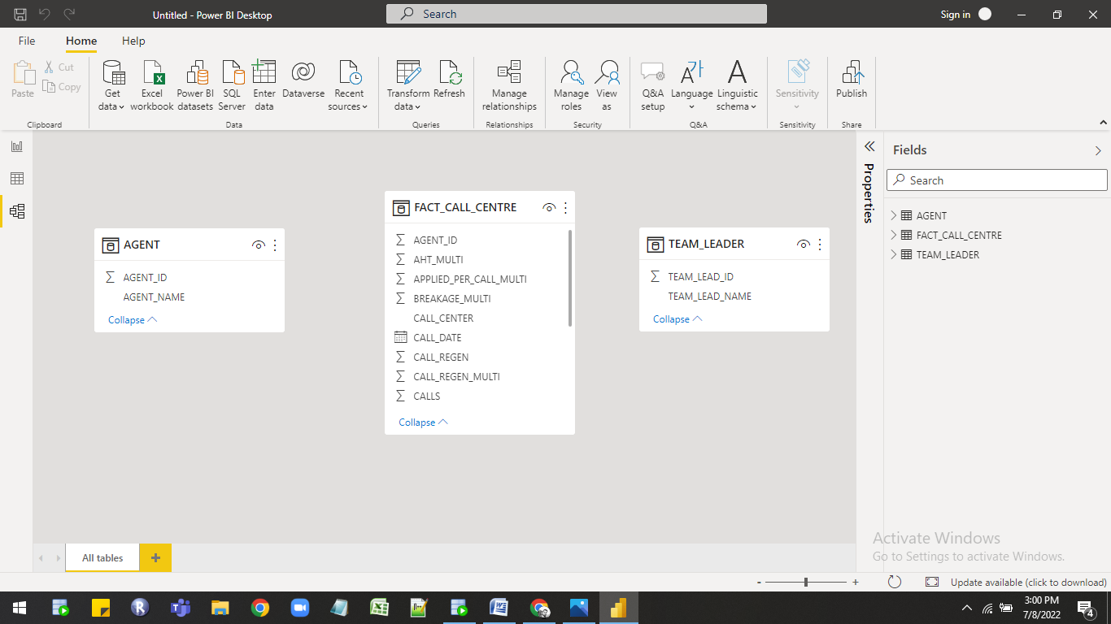

1. Click on New option.

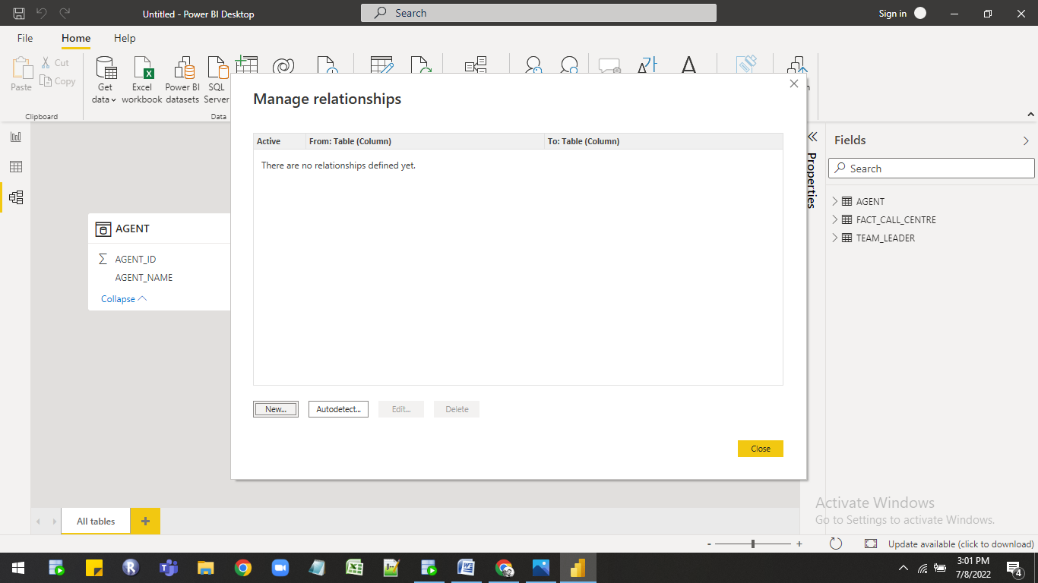

1. Then open new window Create relationship in that select tables and columns that are related then check the cardinality and then check filter direction then click on ok at the end.

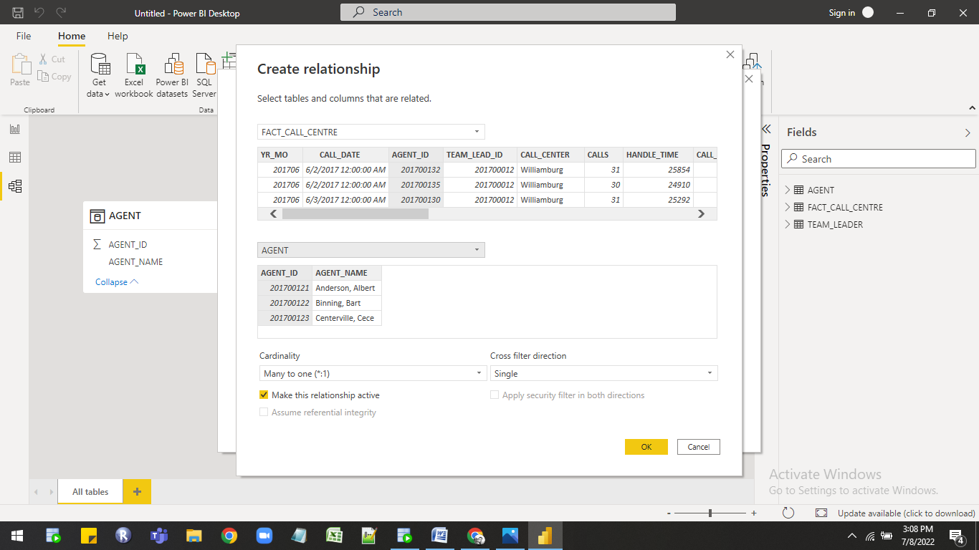

1. Proper data model is created you can see in the image.

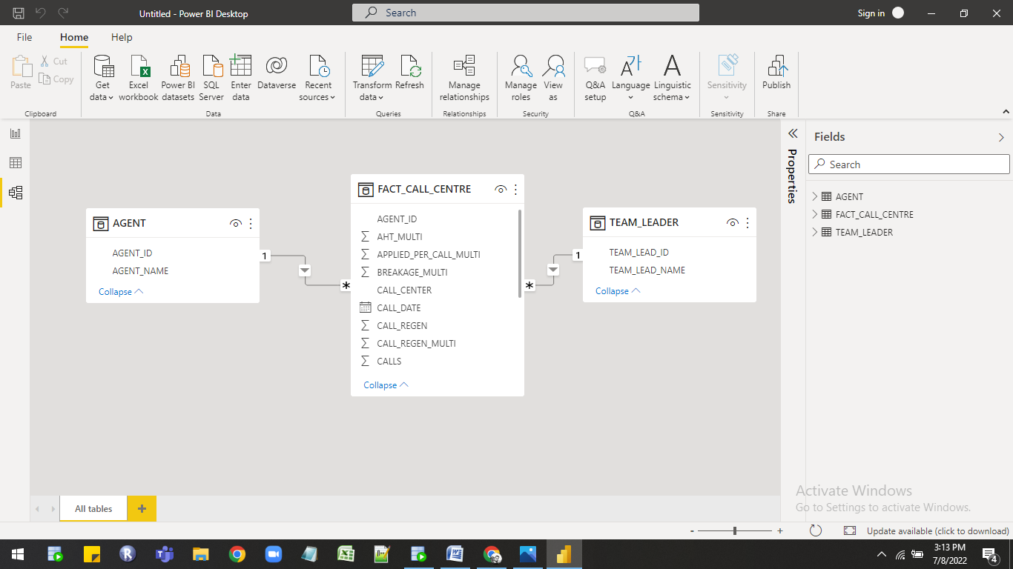

## Business Requirements:-

## Following are the requirements

|  |
| --- |
| Metric |
| Calls Handled |
| Avg Handle Time (or AHT) |
| Transfer % |
| Offer % |
| Accept % |
| Applied % |
| Breakage |
| Applied Per Call % |
| Callback within 2 Days % |

## Required Calculation

For creating report required DAX calculation are as follow

| Sr.No | Dax Measure |
| --- | --- |
| 1 | Total calls = sum(FACT_CALL_CENTRE[CALLS]) |
| 2 | Total handled time = sum (FACT_CALL_CENTRE[HANDLE_TIME]) |
| 3 | Total Transfer = sum(FACT_CALL_CENTRE[TRANSFERS]) |
| 4 | Total call with accept = sum(FACT_CALL_CENTRE[CALLS_WITH_ACCEPT]) |
| 5 | Total Regenerated call = sum(FACT_CALL_CENTRE[CALL_REGEN]) |
| 6 | calls with offer = sum(FACT_CALL_CENTRE[CALLS_WITH_OFFER]) |
| 7 | calls with offer is not applied = [calls with offer]-[calls offer applied] |
| 8 | %accept = DIVIDE([Total call with accept],[calls with offer],0) |
| 9 | %applied = DIVIDE([calls offer applied],[Total call with accept],0) |
| 10 | %offer = divide([calls with offer],[Total calls],0) |
| 11 | Applied Per Call % = divide([calls with offer],[Total calls],0) |
| 12 | Avg handled time = divide ([Total handled time],[Total calls],0) |
| 13 | Breakage = ([Total call with accept]-[calls offer applied])/[Total call with accept] |
| 14 | Callback within 2 Days % = divide([Total Regenerated call],[Total calls],0) |
| 15 | jimson = CALCULATE([Total calls],TEAM_LEADER[TEAM_LEAD_NAME]="Jimson Bill")  %jimson = DIVIDE([jimson],[Total calls],0) |
| 16 | Oferten = CALCULATE([Total calls],TEAM_LEADER[TEAM_LEAD_NAME]="Oferten Quinton")  %Oferten = DIVIDE([Oferten],[Total calls],0) |
| 17 | Winnerson = CALCULATE([Total calls],TEAM_LEADER[TEAM_LEAD_NAME]="Winnerson Aceona")  %winnerson = DIVIDE([Winnerson],[Total calls],0) |

## Report Building :-

As per the requirements next steps is to create report with multiple pages. For creating report the following are the components are used in this report.

Pages In the Report:-

1.Home page:-

Visualization List

| 1 | Cards |
| --- | --- |
| 2 | Slicer |

Feature Used in report

| 1 | Page Navigation |
| --- | --- |
| 2 | Bookmark |
| 3 | Button |
| 4 | Logo,Image |

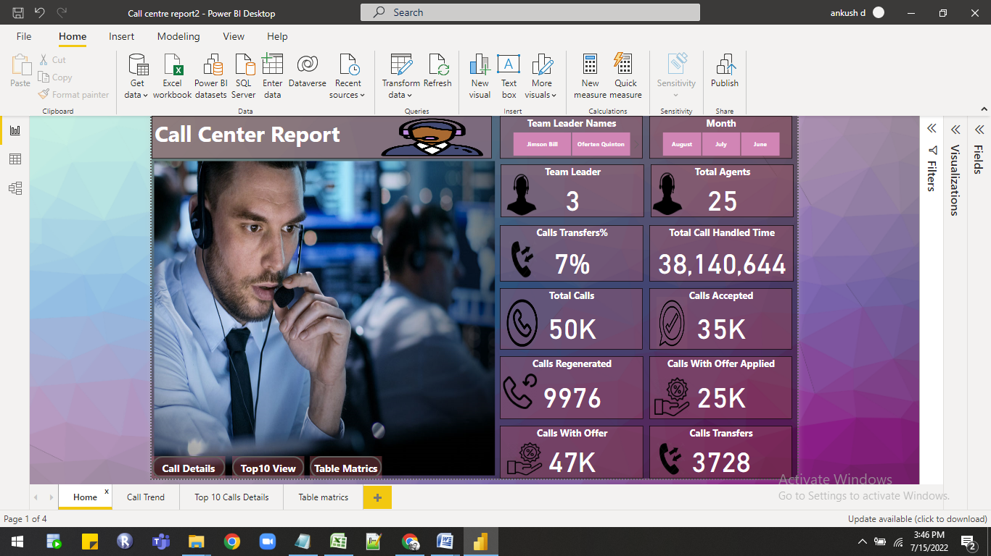

2.Call Trends:-

Visualization List

| 1 | Cards |
| --- | --- |
| 2 | Bar Chart |
| 3 | Column Chart |
| 4 | Line Chart |
| 5 | Tree Map |

Feature Used in report

| 1 | Page Navigation |
| --- | --- |
| 2 | Bookmark |
| 3 | Button |
| 4 | Logo,Image |

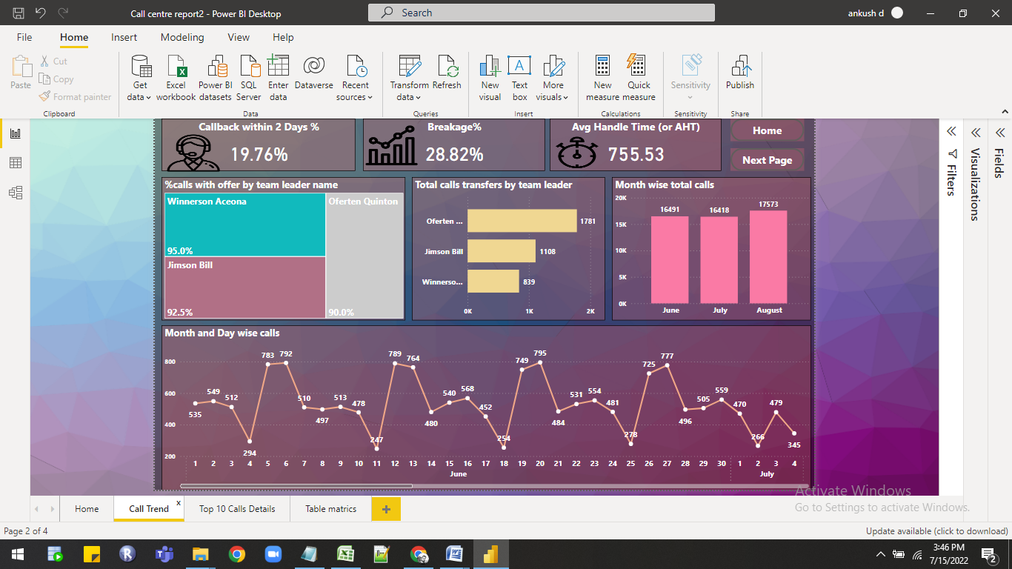

3.Top Call Details:-

Visualization List

| 1 | Cards |
| --- | --- |
| 2 | Bar Chart |
| 3 | Slicer |
| 4 | Table Chart |

Feature Used in report

| 1 | Page Navigation |
| --- | --- |
| 2 | Bookmark |
| 3 | Button |

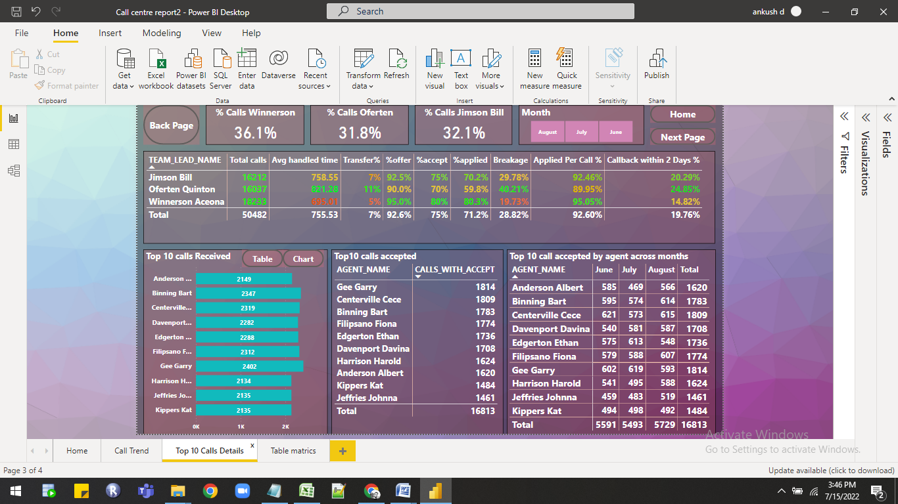

3.Table Matrics:-

Visualization List

| 1 | Cards |
| --- | --- |
| 2 | Slicer |
| 3 | Table Chart |

Feature Used in report

| 1 | Page Navigation |
| --- | --- |
| 2 | Bookmark |
| 3 | Button |



 